SOFTWARE DEVELOPMENT TOOLS

PREPARED BY,

MOHSIN ALI  
MUHAMMAD AMIR  
MUHAMMAD TANEER KHAN  
JUNAID ALI  
ASAD UR REHMAN

CLASS: BSSE (4th SEMESTER)

SECTION: A

* **ANALYSIS TOOLS:**

Software analysis includes all activities, which help the transformation of requirement specification into implementation. Requirement specifications specify all functional and non-functional expectations from the software. These requirement specifications come in the shape of human readable and understandable documents.

**OUR PROJECT:**

We used Microsoft Visio in our project for generating Activity Diagram and Use Case Diagram.

* **MICROSOFT VISIO:**

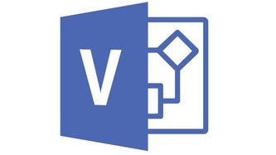

Microsoft Visio is a diagramming and vector graphics application and is part of the Microsoft Office family.

**OTHER TOOLS:**

* **DATA FLOW DIAGRAM:**

Data flow diagram is graphical representation of flow of data in an information system. It is capable of depicting incoming data flow, outgoing data flow and stored data. The Data Flow Diagram does not mention anything about how data flows through the system.

* **STRUCTURE CHARTS:**

Structure chart is a chart derived from Data Flow Diagram. It represents the system in more detail than Data Flow Diagram. It breaks down the entire system into lowest functional modules, describes functions and sub-functions of each module of the system to a greater detail than Data Flow Diagram.

Lucid Chart 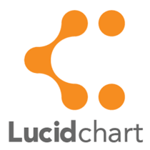 and Visual Paradigm are two examples of tools that are used for analysis.



* **DESIGN TOOLS:**

Software design is a process to transform user requirements into some suitable form, which helps the programmer in software coding and implementation.

**OUR PROJECT:**

We used Microsoft Visio is our project to generate Class Diagram and Sequence Diagram.

* **MICROSOFT VISIO:**

Microsoft Visio is a diagramming and vector graphics application and is part of the Microsoft Office family.

**OTHER TOOLS:**

* **MAGIC DRAW:**

Magic Draw is a visual UML, SysML, BPMN, and UPDM modeling tool with team collaboration support. Designed for business analysts, software analysts, programmers, and QA engineers, this dynamic and versatile development tool facilitates analysis and design of object oriented systems and databases.

* **VISUAL PARADIGM:**

Visual Paradigm is a UML CASE Tool supporting UML 2, SysML and Business Process Modeling Notation from the Object Management Group. In addition to modeling support, it provides report generation and code engineering capabilities including code generation.

* **PAPYRUS:**



Papyrus can either be used as a standalone tool or as an Eclipse plugin. It provides support for [Domain Specific Languages](https://en.wikipedia.org/wiki/Domain-specific_language) and [SysML](https://en.wikipedia.org/wiki/SysML). Papyrus is designed to be easily extensible as it is based on the principle of [UML Profiles](https://en.wikipedia.org/wiki/Profile_(UML)).

* **PROJECT MANAGEMENT TOOLS:**

Project management includes developing a project plan, which involves defining and confirming the project goals and objectives, how they will be achieved, identifying tasks and quantifying the resources needed, and determining budgets and timelines for completion.

**OUR PROJECT:**

We used Microsoft Project for creating Gantt chart, Pert Chart and Timeline in our Project Management.

* **MICROSOFT PROJECT:**

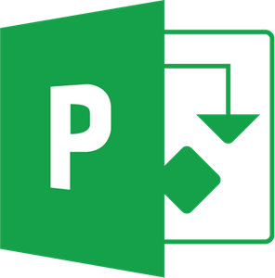

Microsoft Project is a [project management software](https://en.wikipedia.org/wiki/Project_management_software) product, developed and sold by [Microsoft](https://en.wikipedia.org/wiki/Microsoft). It is designed to assist a [project manager](https://en.wikipedia.org/wiki/Project_manager) in developing a [plan](https://en.wikipedia.org/wiki/Plan), assigning [resources](https://en.wikipedia.org/wiki/Resource_(project_management)) to tasks, tracking progress, managing the [budget](https://en.wikipedia.org/wiki/Budget), Gantt charts and analyzing workloads

**OTHER TOOLS:**

* **REDMINE:**

Redmine is a free and open source, web-based project management and issue tracking tool. It allows users to manage multiple projects and associated subprojects. It features per project wikis and forums, time tracking, and flexible, role-based access control.



* **ZOHO OFFICE SUITE:**



Zoho Office Suite is a web-based online office suite containing word processing, spreadsheets, presentations, databases, note-taking, wikis, web conferencing, customer relationship management, project management, invoicing, and other applications.

* **EASY PROJECTS:**

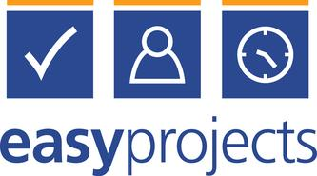

Easy Projects provides functionality common to software designed for [Project Management](https://en.wikipedia.org/wiki/Project_Management) and [Collaboration](https://en.wikipedia.org/wiki/Collaboration) including configurable [Dashboards](https://en.wikipedia.org/wiki/Dashboard), Integrated Reporting, [Message boards](https://en.wikipedia.org/wiki/Message_board), issue and request tracking, statistics, email notifications, and [Gantt charts](https://en.wikipedia.org/wiki/Gantt_chart).

* **DATABASE MANAGEMENT TOOLS:**

A database management system (DBMS) is system software for creating and managing [databases](https://searchsqlserver.techtarget.com/definition/database). The DBMS provides users and programmers with a systematic way to create, retrieve, update and manage [data](https://searchdatamanagement.techtarget.com/definition/data).

**OUR PROJECT:**

We used Microsoft Access in our project for managing data.

* **MICROSOFT ACCESS:**

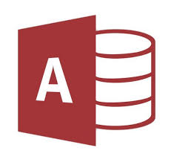

Microsoft Access is a database management system from Microsoft that combines the relational Microsoft Jet Database Engine with a graphical user interface and software-development tools.

**OTHER TOOLS:**

* **MICROSOFT SQL SERVER:**

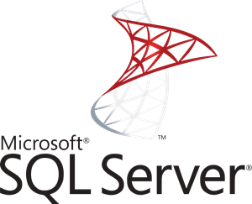

Microsoft SQL Server is a relational database management system developed by Microsoft. As a database server, it is a software product with the primary function of storing and retrieving data as requested by other software applications which may run either on the same computer or on another computer across a network.

* **ORACLE DATABASE:**

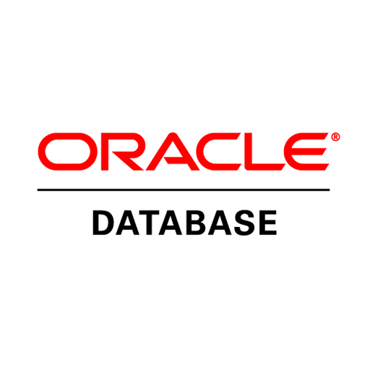

Oracle Database is a multi-model database management system produced and marketed by Oracle Corporation. It is a database commonly used for running online transaction processing, data warehousing and mixed database workloads.

* **DOCUMENTATION TOOLS:**

Software documentation is written text or illustration that accompanies [computer software](https://en.wikipedia.org/wiki/Computer_software) or is embedded in the source code. It either explains how it operates or how to use it or may mean different things to people in different roles.

[Documentation](https://en.wikipedia.org/wiki/Documentation) is an important part of [software engineering](https://en.wikipedia.org/wiki/Software_engineering). Types of documentation include:

* [Requirements](https://en.wikipedia.org/wiki/Requirement): Statements that identify attributes, capabilities, characteristics, or qualities of a system. This is the foundation for what will be or has been implemented.
* Design: Overview of software. Includes relations to an environment and construction principles to be used in design of software components.
* Technical: Documentation of code, algorithms, interfaces, and [APIs](https://en.wikipedia.org/wiki/API_documentation).
* [End user](https://en.wikipedia.org/wiki/End_user): Manuals for the end-user, system administrators and support staff.
* Marketing: How to market the product and analysis of the market demand.

**OUR PROJECT:**

We used Microsoft Word for documentation of our project.

* **MICROSOFT WORD:**



Microsoft Word is a [word processor](https://en.wikipedia.org/wiki/Word_processor) developed by [Microsoft](https://en.wikipedia.org/wiki/Microsoft).

**OTHER TOOLS:**



* **MARKDOWNPAD:**

**MarkdownPad**is a full-featured [Markdown](http://markdownpad.com/#whatIsMarkdown) editor for Windows.

* **DROPBOX PAPER:**



Dropbox Paper, or simply Paper, is a [collaborative](https://en.wikipedia.org/wiki/Collaborative) document-editing service developed by [Dropbox](https://en.wikipedia.org/wiki/Dropbox_(service)).

* **READ THE DOCS:**

Read the Docs simplifies software documentation by automating building, versioning, and hosting of your docs for you.

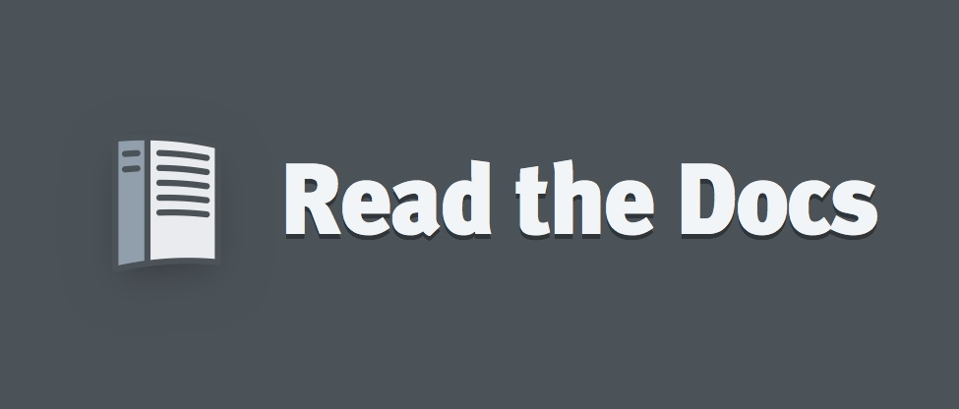

* **SEQUENCE & ACTIVITY DIAGRAM:**

**SEQUENCE DIAGRAM:**



**ACTIVITY DIAGRAM:**

